Greg's thoughts on integrating my MS Word installation guide with the official online Wiki

Reference:

Import...
Recommend including screenshots of the Import ... screen by screen. Without it, people get confused.
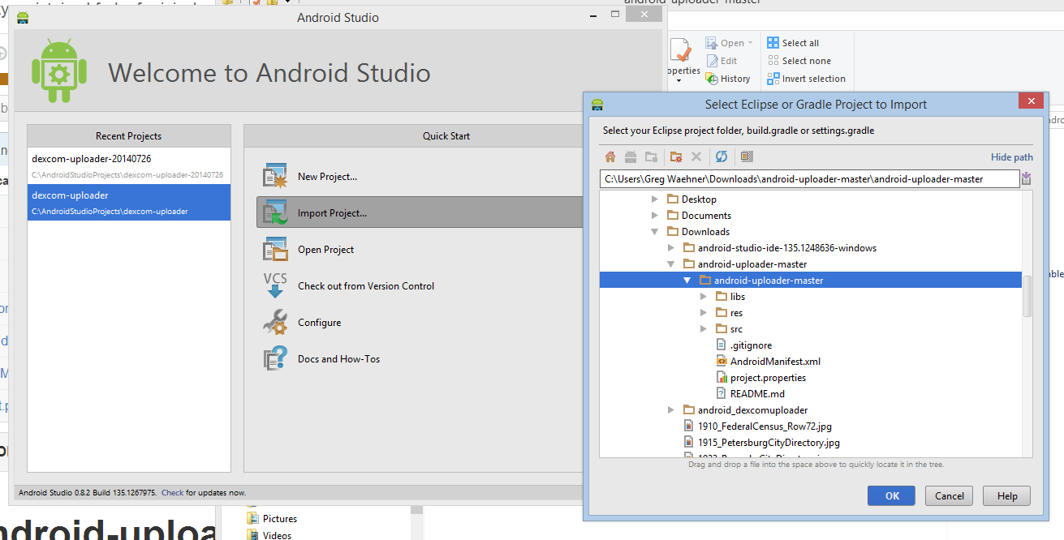

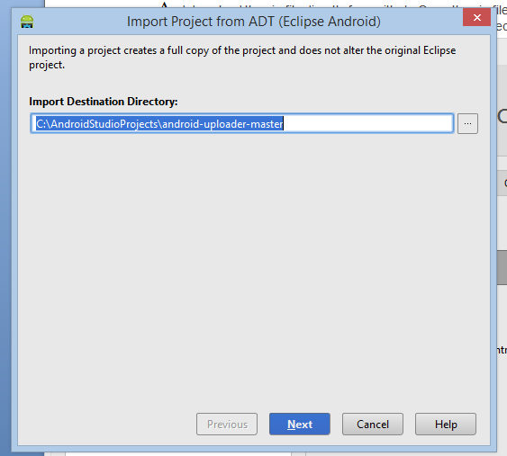
(Note.... I configured Android Studio to use an easy to find location... C:\AndroidStudioProjects\)

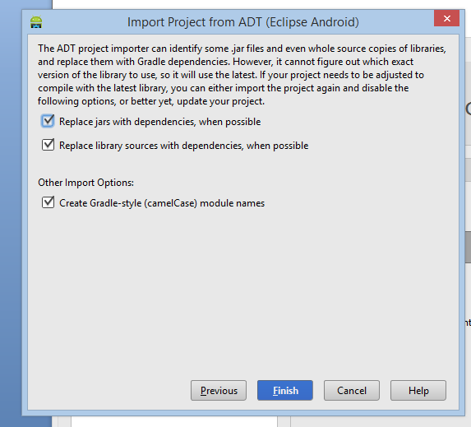
Note - leave everything "checked"

SDK Update.... Add API 18...
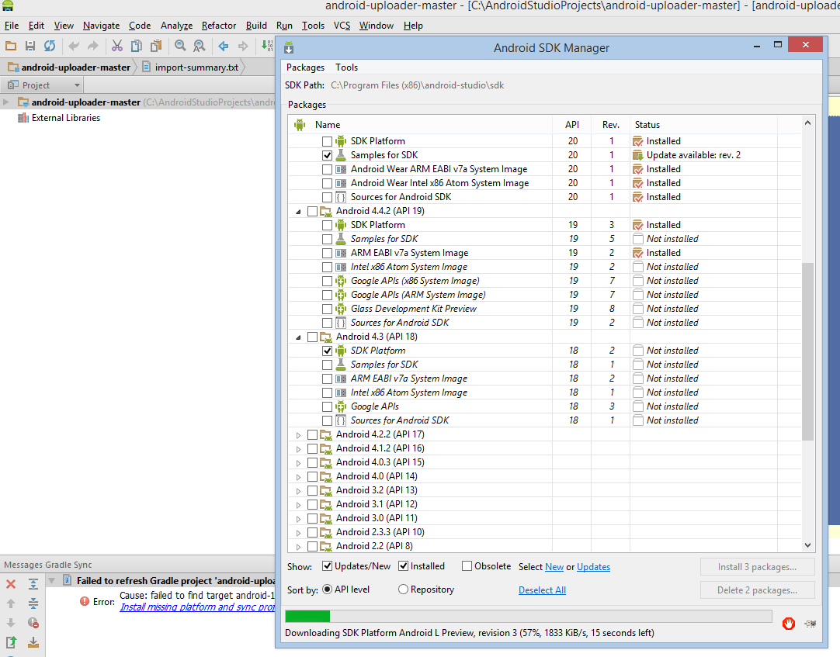

But after I did that (just now), I got an error ....
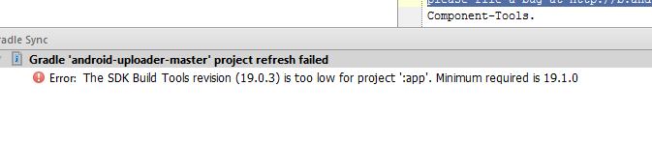
So I went back into SDK Manager and choose (at the top)..
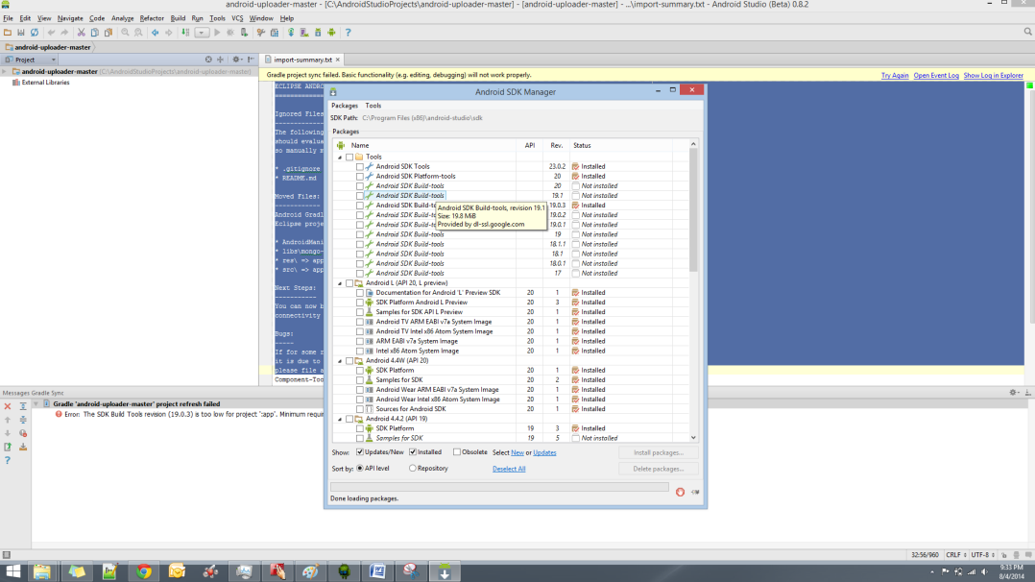

Still didn't work.
Answer: http://stackoverflow.com/questions/24093561/how-to-force-android-studio-0-6-0-to-use-sdk-build-tools-19-1-0

See screenshot... I had to modify the "build.gradle" file that was part of the new "android-uploader" to work.... from 19.0.3 to 19.1.0...
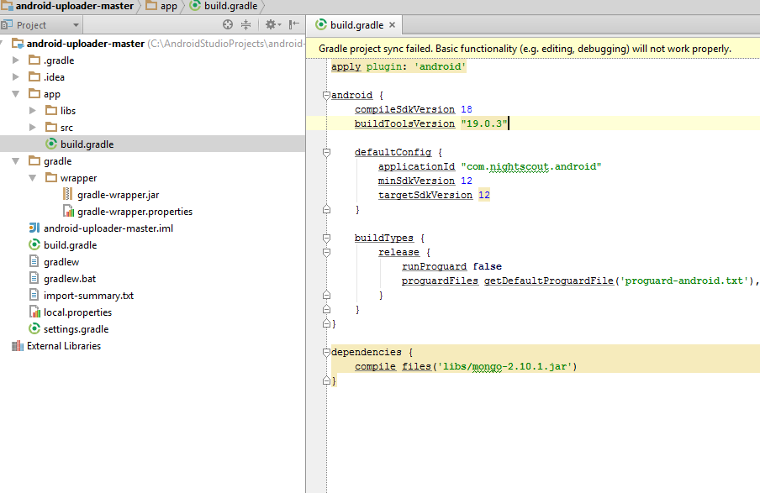

I'm using Android Studio (Beta) 0.8.2.... Note... the link in Wiki goes to "0.8.0"... but when you download all updates... My edits to build.gradle make it work fine... but I don't know where the 19.0.3 is coming from... unless we need to tell people to ensure SDK Build Tools 19.1.0 as part of the upfront SDK updates BEFORE importing ????

