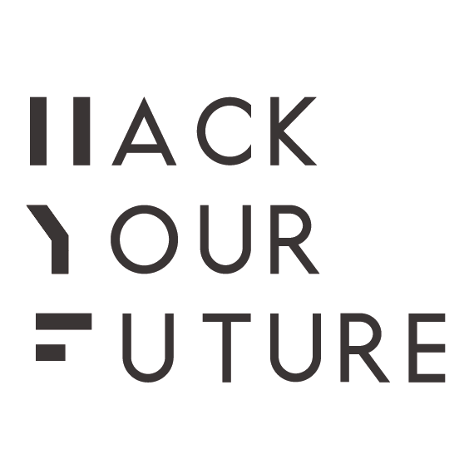

Dear applicants,

You’ve come far in the selection procedure of HackYourFuture!

You are one of the top applicants, in the end we will select up to 10 candidates for our program starting in October. At HackYourFuture we’re really looking for people who work hard, and are determined and passionate about coding. We’re not looking for people who’d like to do coding as a hobby. In order to test your skills and determination, we believe the best way is to already start with letting you code something very basic. Don’t worry, it’s not going to be very hard, but it might be challenging.
We want you to do exercises on http://www.freecodecamp.com/. Freecodecamp is a website on which you learn how to code, step-by-step, in your browser.

Step 1. Go to freecodecamp.com

Step 2. Sign in

Step 3. Start doing all the exercises in the subjects HTML5 and CSS and Responsive Design with bootstrap: (you can see all exercises by clicking on “map” in the top bar. Click on the triangle, to show all the exercises per subject)

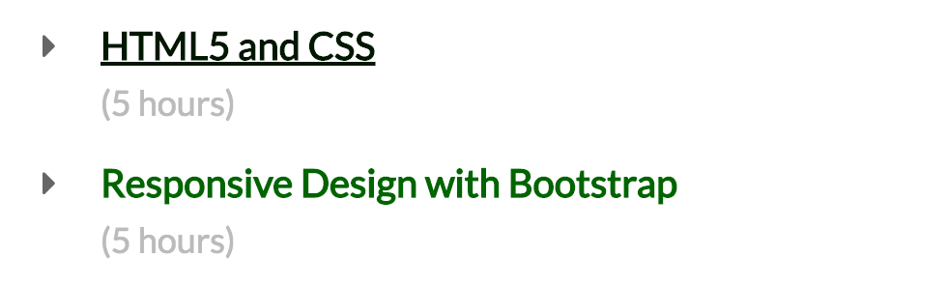

Here you learn the fundamentals of building a website.

Step 4. (IMPORTANT) Do the assignment: Build a tribute page in the section Basic Front End development Projects. You make this on codepen.io. It doesn’t have to be a professional website, but we like to see your newly learned skills. Please don’t copy your code! And try to make your page responsive. As soon as you are finished, you can send a link to your project to info@hackyourfuture.net. Also send me your freecodecamp username, so I can see your work in Freecodecamp.

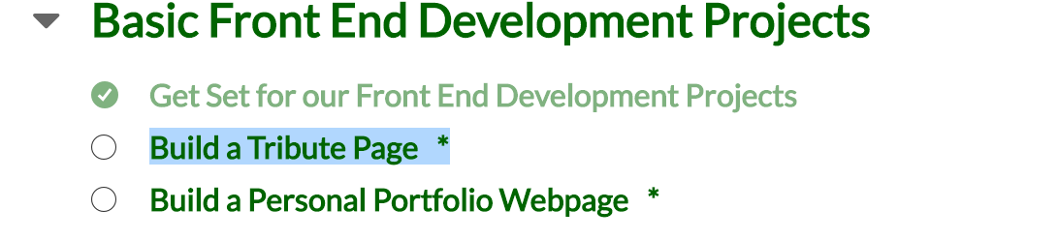

The deadline is the 4th of October to hand in your assignment and username. Send it to london@hackyourfuture.net.
Your email should contain:
- Your freecodecamp username (link)
- A link to your tribute page
Based on this work, we will make our final selection if you can join our course. Make sure to impress us!

If you have any questions please email me via german@hackyourfuture.net ,

Good luck!

Germán D’Jesús
London - HackYourFuture

